**Event Management DB**

To develop the application that allows users to create and manage events, track

attendees, and handle event registrations efficiently.

1. **Database Creation**

-- Create Database

CREATE DATABASE EventsManagement;

-- Create Events Table

CREATE TABLE Events (

Event_Id INTEGER PRIMARY KEY,

Event_Name TEXT NOT NULL,

Event_Date DATE NOT NULL,

Event_Location TEXT NOT NULL,

Event_Description TEXT

);

-- Create Attendees Table

CREATE TABLE Attendees (

Attendee_Id INTEGER PRIMARY KEY,

Attendee_Name TEXT NOT NULL,

Attendee_Phone NUMERIC(10),

Attendee_Email TEXT UNIQUE,

Attendee_City TEXT

);

-- Create Registrations Table with Foreign Keys

CREATE TABLE Registrations (

Registration_id INTEGER PRIMARY KEY,

Event_Id INTEGER REFERENCES Events(Event_Id),

Attendee_Id INTEGER REFERENCES Attendees(Attendee_Id),

Registration_Date DATE DEFAULT CURRENT_DATE,

Registration_Amount NUMERIC(10,2),

FOREIGN KEY (Event_Id) REFERENCES Events(Event_Id),

FOREIGN KEY (Attendee_Id) REFERENCES Attendees(Attendee_Id)

);

-- Create Indexes for better performance

CREATE INDEX idx_event_name ON Events(Event_Name);

CREATE INDEX idx_event_date ON Events(Event_Date);

CREATE INDEX idx_attendee_name ON Attendees(Attendee_Name);

CREATE INDEX idx_registration_date ON Registrations(Registration_Date);

1. **Data Creation**

-- Insert data into Events table

INSERT INTO Events (Event_Id, Event_Name, Event_Date, Event_Location, Event_Description) VALUES

(1, 'Tech Summit 2024', '2024-07-15', 'Chennai Trade Centre', 'Annual technology conference with industry experts'),

(2, 'Music Festival', '2024-08-20', 'Marina Beach', 'Open-air music festival featuring local artists'),

(3, 'Food Expo', '2024-09-10', 'Chennai Convention Centre', 'International food and beverage exhibition'),

(4, 'Digital Marketing Workshop', '2024-07-25', 'ITC Grand Chola', 'Hands-on workshop on digital marketing strategies'),

(5, 'Startup Meet', '2024-08-05', 'Anna Centenary Library', 'Networking event for startups and investors');

-- Insert data into Attendees table

INSERT INTO Attendees (Attendee_Id, Attendee_Name, Attendee_Phone, Attendee_Email, Attendee_City) VALUES

(101, 'Rajesh Kumar', 9876543210, 'rajesh.k@email.com', 'Chennai'),

(102, 'Priya Mehta', 9876543211, 'priya.m@email.com', 'Bangalore'),

(103, 'Arun Sharma', 9876543212, 'arun.s@email.com', 'Chennai'),

(104, 'Deepa Venkat', 9876543213, 'deepa.v@email.com', 'Coimbatore'),

(105, 'Karthik Raja', 9876543214, 'karthik.r@email.com', 'Chennai'),

(106, 'Meena Kumari', 9876543215, 'meena.k@email.com', 'Madurai'),

(107, 'Suresh Babu', 9876543216, 'suresh.b@email.com', 'Chennai'),

(108, 'Lakshmi Priya', 9876543217, 'lakshmi.p@email.com', 'Salem');

-- Insert data into Registrations table

INSERT INTO Registrations (Registration_id, Event_Id, Attendee_Id, Registration_Date, Registration_Amount) VALUES

(1001, 1, 101, '2024-06-01', 1500.00),

(1002, 1, 102, '2024-06-02', 1500.00),

(1003, 2, 103, '2024-06-05', 750.00),

(1004, 2, 104, '2024-06-05', 750.00),

(1005, 3, 105, '2024-06-10', 1000.00),

(1006, 3, 106, '2024-06-10', 1000.00),

(1007, 4, 107, '2024-06-15', 2000.00),

(1008, 4, 108, '2024-06-15', 2000.00),

(1009, 5, 101, '2024-06-20', 500.00),

(1010, 5, 103, '2024-06-20', 500.00),

(1011, 1, 105, '2024-06-21', 1500.00),

(1012, 2, 107, '2024-06-22', 750.00);

1. **Manage Event Details**
2. Inserting a new event.

INSERT INTO Events (Event_Id, Event_Name, Event_Date, Event_Location, Event_Description) VALUES

(6, 'Food Festival', '2024-09-04', 'Chennai Trade Centre', 'Food Tasting and manufacturing innovations');

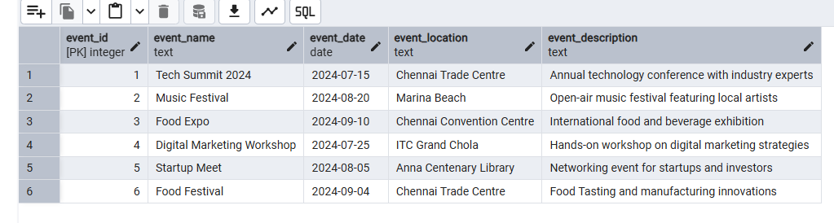

1. Updating an event's information.

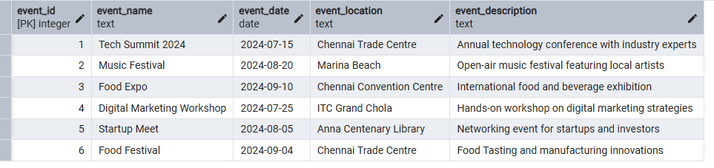

UPDATE events SET event_date = '2025-10-04' WHERE event_id = 6;

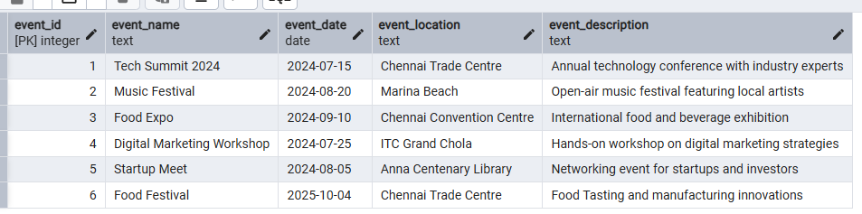

1. Deleting an event.

DELETE FROM Events WHERE Event_Id = 6;

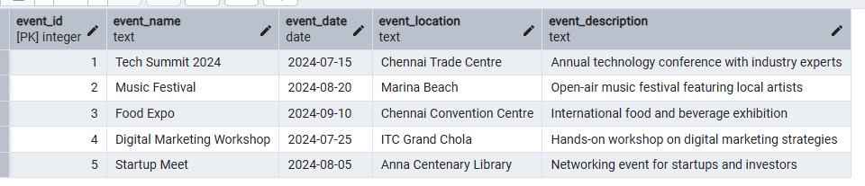

1. **Manage Track Attendees & Handle Events**

4) Manage Track Attendees & Handle Events

select

r.registration_date

, r.registration_amount

, e.event_id

, e.event_name

, e.event_date

, e.event_location

, e.event_description

, a.attendee_name

, a.attendee_phone

, a.attendee_email

, a.attendee_city

from registrations as r

inner join events as e

on r.event_id = e.event_id

inner join attendees as a

on r.attendee_id = a.attendee_id

;

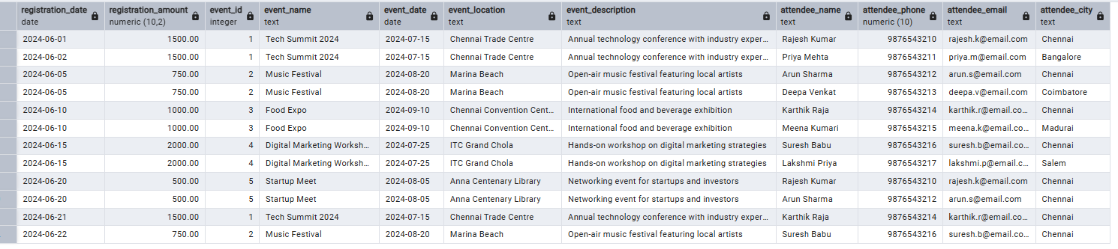

1. Inserting a new attendee.

INSERT INTO Attendees (Attendee_Id, Attendee_Name, Attendee_Phone, Attendee_Email, Attendee_City) VALUES

(109, 'Ram Kumar', '9785637218', 'ramk@email.com', 'Porur');

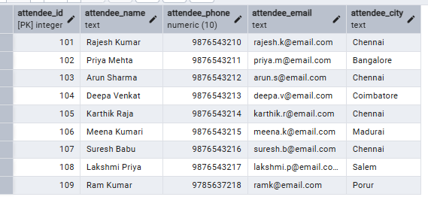

1. Registering an attendee for an event.

INSERT INTO Registrations (Registration_id, Event_Id, Attendee_Id, Registration_Date, Registration_Amount) VALUES

(1013, 5, 109, '2024-06-20', 500.00);

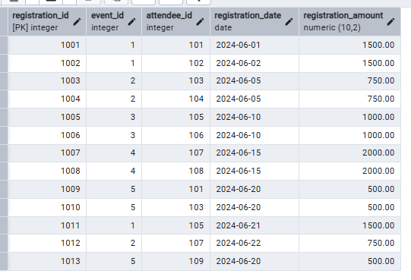

**5. Develop queries to retrieve event information, generate attendee lists, and calculate event attendance statistics.**

-- . Retrieve basic event information

SELECT

Event_Id,

Event_Name,

Event_Date,

Event_Location,

Event_Description

FROM

Events

ORDER BY

Event_Date;

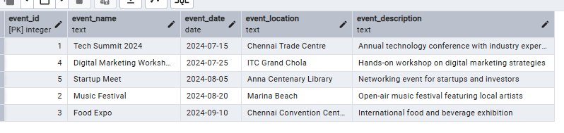

-- . Generate attendee list for a specific event

SELECT

a.Attendee_Name,

a.Attendee_Email,

a.Attendee_City,

r.Registration_Date

FROM

Attendees a

JOIN Registrations r ON a.Attendee_Id = r.Attendee_Id

WHERE

r.Event_Id = 1

ORDER BY

a.Attendee_Name;

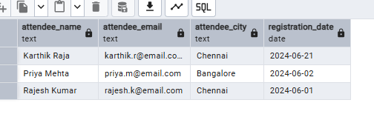

-- . Calculate total attendees and revenue for each event

SELECT

e.Event_Id,

e.Event_Name,

COUNT(r.Attendee_Id) as Total_Attendees,

SUM(r.Registration_Amount) as Total_Revenue

FROM

Events e

LEFT JOIN Registrations r ON e.Event_Id = r.Event_Id

GROUP BY

e.Event_Id, e.Event_Name

ORDER BY

Total_Attendees DESC;

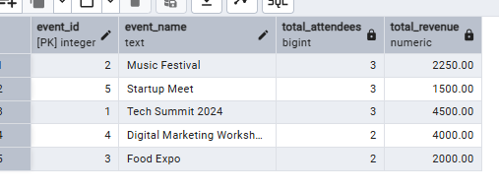

-- . Calculate attendance statistics by city

SELECT

a.Attendee_City,

COUNT(DISTINCT r.Attendee_Id) as Total_Attendees,

COUNT(DISTINCT r.Event_Id) as Events_Attended

FROM

Attendees a

JOIN Registrations r ON a.Attendee_Id = r.Attendee_Id

GROUP BY

a.Attendee_City

ORDER BY

Total_Attendees DESC;

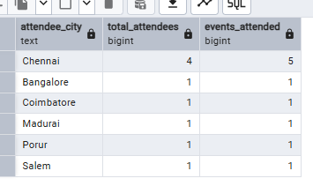

-- . Find the most popular events (by attendance)

SELECT

e.Event_Name,

COUNT(r.Attendee_Id) as Attendee_Count

FROM

Events e

LEFT JOIN Registrations r ON e.Event_Id = r.Event_Id

GROUP BY

e.Event_Name

ORDER BY

Attendee_Count DESC

LIMIT 5;

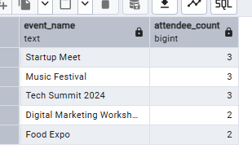

.-- Find attendees who have registered for multiple events

SELECT

a.Attendee_Name,

COUNT(DISTINCT r.Event_Id) as Events_Registered

FROM

Attendees a

JOIN Registrations r ON a.Attendee_Id = r.Attendee_Id

GROUP BY

a.Attendee_Id, a.Attendee_Name

HAVING

COUNT(DISTINCT r.Event_Id) > 1

ORDER BY

Events_Registered DESC;

